Technical Specification

WRICEF ID.: | Emplicit enhancement
Project Name: | Support
Client Name: | Everenviro
WRICEF Description: | Emplicit enhancement for smartform display for tcode va02 and va03 (specific output type)

TECHNICAL SPECIFICATION

Section 1: General Information
Project: | Support Project | Functional Area: | SD
VSD Functional Consultant | Harish Giri and Rohit Mahaveer | VSD Developer | Shivani Jha
Object Name: | ZSD_OTC_DRV_PRG and ZSD_ENH_ADR_PAN_VALIDATION
Object Id | Enhancement
Description | Emplicit enhancement for smartform display for va02 and va03 tcode (for specific output type) and validation for cust. reference and telebox in va01 and va02 tcode (for specific order type)
Development Class |  |  |  | Package
Package | ZSD
File Name & Location in Solution Manager for FSD
File Name & Location in Solution Manager for TSD
Menu Path: (if applicable)
Mode | Foreground Background
Frequency | Monthly Weekly Daily Adhoc Others
Title:
Application Key: | NA
Complexity: | High Medium Low

Table of Contents
1 Scope Summary 5
1.1 Development Objects per System 5
2 Business Details 6
2.1 Summary / Business Background 6
2.2 Assumptions 6
3 Development Scope 7
3.1.1 Detailed Process Description 7
3.1.2 Data Model 7
3.2 Web Service - NA 7
3.2.1 Configuration 7
3.2.2 Development Objects 7
3.2.3 Business Logic 7
3.2.4 Error Handling 7
3.3 Workflow Development - NA 8
3.3.1 Configuration 8
3.3.2 Business Object creation / extension 8
3.3.3 Triggering Mechanism 8
3.3.4 Creation/Change of Workflow 8
3.3.5 Workflow Business Logic 8
3.3.6 Error Handling 8
3.4 Reports 8
3.4.1 Selection Screen 8
3.4.2 Business Logic 8
3.4.3 Output Format 8
3.4.4 Run Mode 8
3.4.5 Error Handling 8
3.5 Forms - NA 9
3.5.1 Layout Details / Sample Formats 9
3.5.2 Business Logic for Data Retrieval 9
3.5.3 Triggering Mechanism 9
3.5.4 Special Considerations 9
3.5.5 Error Handling 9
3.6 Dialog program / Web Developments (PCUI - BSP / WebDynpro) - NA 9
3.6.1 General 9
3.6.2 Screen Sequence 9
3.6.3 Business Logic 9
3.6.4 Bespoke Tables Updated 9
3.6.5 Error Handling 9
3.6.6 Multi-User Access Consideration 9
3.6.7 Branding Requirements 9
3.6.8 Screen layout 9
3.6.9 Field Definition 9
3.6.10 Menu implementation 9
3.6.11 Database update processing 10
3.7 Enhancements - 10
3.7.1 List of Enhancements 10
3.7.2 Business Logic 10
3.8 SAP PI – ABAP Proxy Development - NA 10
3.9 Class / Interface Development - NA 10
3.10 IDOC Development - NA 11
3.10.1 General 11
3.10.2 IDoc Customizing 11
3.10.3 Record Layout 11
3.10.4 Extension 11
3.10.5 IDoc Type 11
3.10.6 Message Type 11
3.10.7 Logical System 12
3.10.8 Process Code 12
3.10.9 Distribution Model 12
3.10.10 Transactional RFC Port 12
3.10.11 File Port 12
3.10.12 XML File port 12
3.10.13 XML HTTP 12
3.10.14 Partner profile 13
3.10.15 Inbound/outbound Parameters 13
3.10.16 Message Control 13
3.10.17 IDoc Processing 13
3.10.18 ABAP Processing 13
3.10.19 Description of Output 13
3.10.20 Programs/function modules for creation of IDOCs 14
3.10.21 Error handling for inbound/outbound (link to any workflow developments) 14
3.10.22 FTP scripting requirements 14
3.11 Function Module / RFC / BAPI - NA 14
3.12 Data Dictionary Objects - NA 16
3.12.1 Bespoke Table 16
3.12.2 Search helps 17
3.12.3 Lock Objects 17
3.13 Actions - NA 17
4 Authorizations 18
5 Message Class and Messages 19
6 Archiving – NA 20
7 Unit Test 21
7.1 Unit Test Specification 21
7.2 Test Data or Sample file 21
8 Version Control 22
9 Glossary - NA 23

Business Details

Summary / Business Background

Title | 1.Emplicit enhancement for smartform display for va02 and va03 transaction 2.Validation for cust referance and telebox for tcode va01 and va02 for specific order type ZFOM
Description | 1.Emplicit enhancement for smartform display for va02 and va03 transaction for specific output type  2. Validation for cust referance and telebox for tcode va01 and va02 for specific order type ZFOM
Business purpose | 1.Emplicit enhancement for smartform display for va02 and va03 transaction for specific output type  2. Validation for cust referance and telebox for tcode va01 and va02 for specific order type ZFOM
Application area | SD
Tcode | VA01,VA02 and VA03

Forms -

Business Logic for Data Retrieval
Create the replica of form and its driver program that is (ZSD_SALES_ORDER and ZSD_SALE_ORDER)
the new form is (ZSD_SALES_ORDER_FORM_OTC and driver program is ZSD_OTC_DRV_PRG) .
As per the req. order type (ZFOM) add condition and change cutomer name,address,adhar no.,
pan card no. in smartform and driver program.

Triggering Mechanism
Form is display using tcode va02 and va03.

Enhancements -

List of Enhancements - Emplicit enhancement for form display for tcode va02
and va03
Enhancement for validation cust referance and telebox for tcode va01
and va02

Business Logic - Enhancement logic for va02 and va03 tcode
As per assign output type(ZFOM) in nace tcode above created form
is display which has sales order details.
Enhancement logic for va01 and va02.
After clicking save button when create and change sales order through tcode
va01 and va02 cust. reference and telebox should be checked for order
type ZFOM.

Validation 1. Cust. reference length should be 12 and only contain only number other wise
error message will display, after correction of error message will able to
create and change sales order.
2. Telebox length should be 10 and contain only alphanumeric other wise
error message will display, after correction of error message will able to
create and change sales order.

2 Unit Test (Enhancement for va02 and va03)

Unit Test Specification -
Go to tcode VA02 or VA03 ->enter sales order no. -> click on sales document -> issue o/p to -> select o/p type ->
print preview.

Test Data or Sample file
Below is the process for taking printout
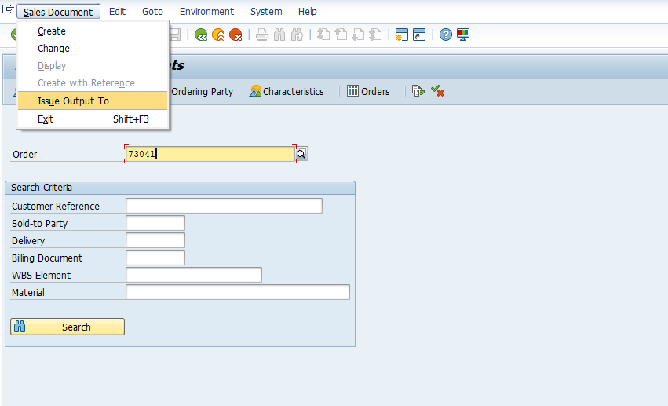
select assigned output type

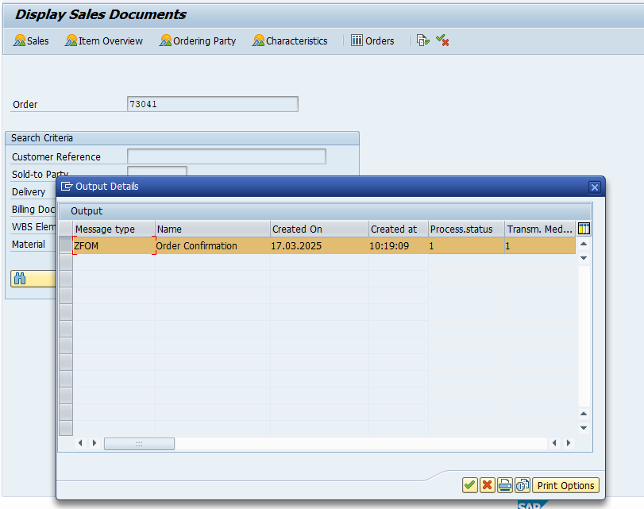

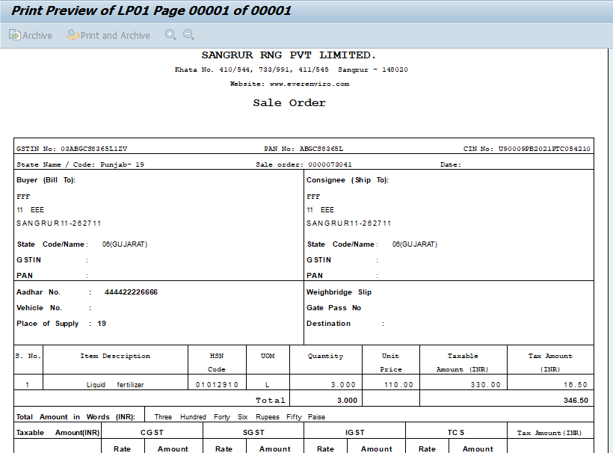

2. Unit Test Specification (for va01 and va02 tcode )

When create and change sales order through tcode va01 and va02---

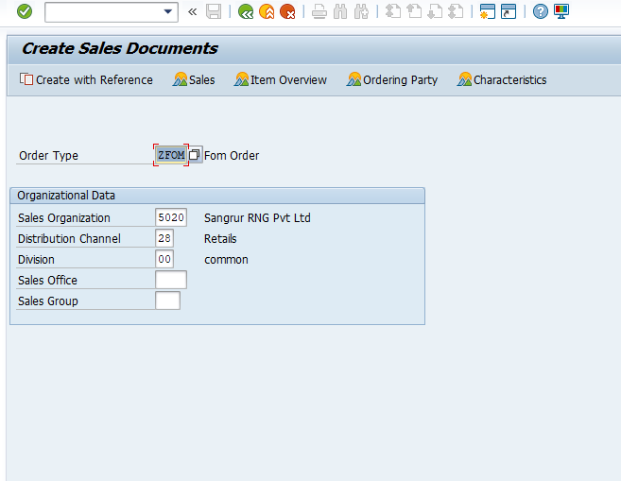

Here Cust reference length is less than 12, error message displayed.

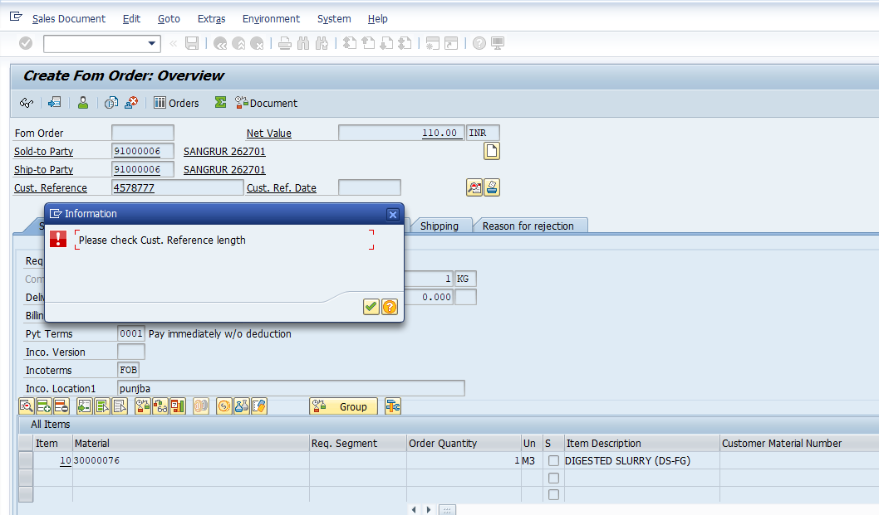

Here at place of cust. reference alphanumeric value, below error message displayed.

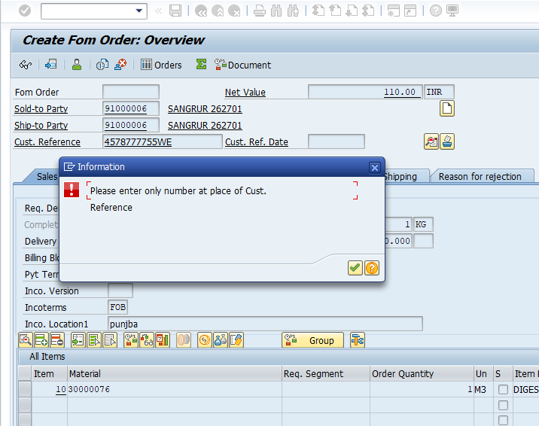

Here at place of telebox length is less than 10, error message displayed.

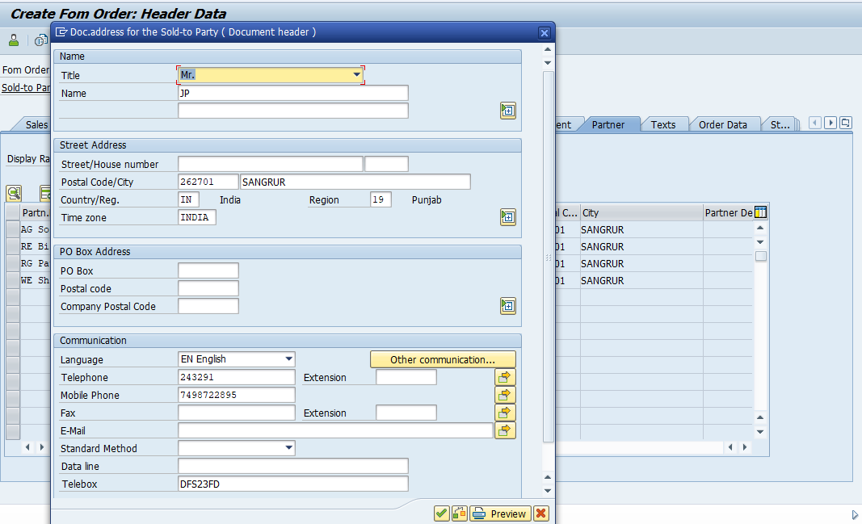

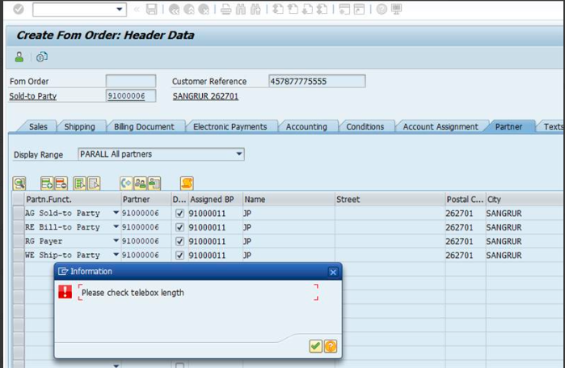

Version Control
Version | Date | Comment/Changes | Completed By | Transport
807 | 10.03.2025 | VSD: driver pgm - one time customer (SO) on 10.03.25 | Shivani Jha | DS4K903606

